**PRESENT SIMPLE vs.**

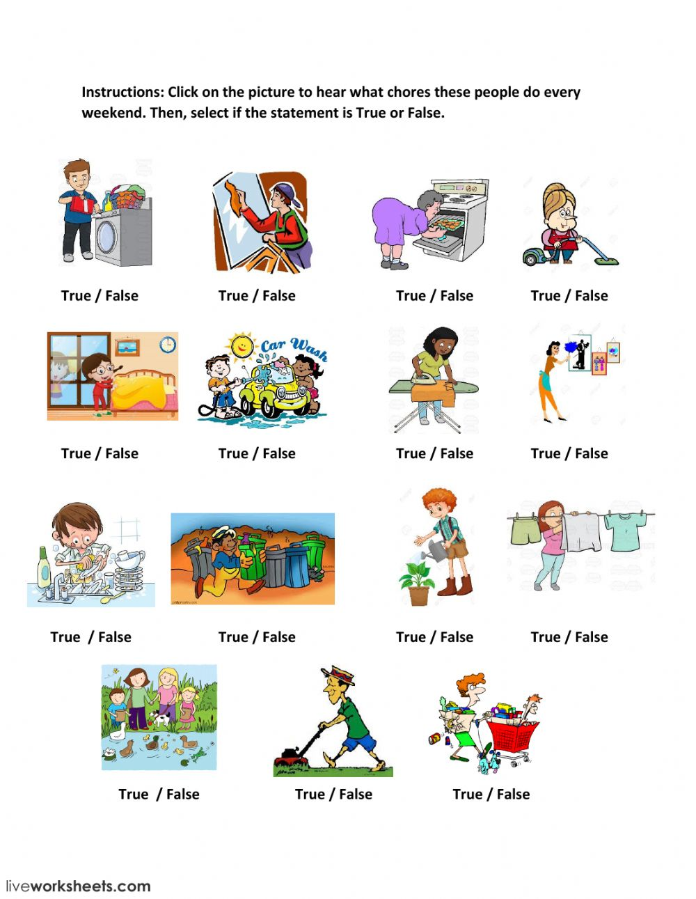

**PRESENT CONTINUOUS**

